Document Number: GAS-1133
Revision: H

Table of Contents
Introduction 2
Configuration Testing 2
Create User Accounts 3
Configure Module Access Lists 3
Authorize Access to Intended Items 5
Open Task Assignments 5
Design Projects 6
Document Collections 9

Introduction
These instructions are for configuring Grand Avenue Software (GAS) so that auditors, customers, suppliers, and/or external contractors can have user accounts in your GAS quality system, but their access is limited to only items you specify. In this document, they are called “limited access” users.

This procedure is divided into 4 main sections:
- Create user accounts for limited access users
- Configure Module Access Lists to block the users’ access to designated modules
- Identify the items that each limited access user may view, keeping the following in mind:
- Users who are otherwise blocked by module access lists have temporary access to items associated with open tasks assigned to them (e.g., Formal Review, Complete Training, Approve Disposition).
- Users who are otherwise blocked by the Document Control Module Access List are authorized to view the documents in any document collections where they are the Document Collection Owner or a Document Collection Viewer.
  - NOTE: Document Collection Viewers are applicable to GAS Versions 15.6 and later.
- Users who are otherwise blocked by the Design Control Module Access List are authorized to view deliverables in open design projects for which they are a Project Viewer.
- Test the configuration

Configuration Testing
NOTE: Before sending login information to individuals who will have limited access to Grand Avenue, test your configuration in a non-production environment and verify that the user accounts are authorized to see the intended items and nothing additional. Once you’ve verified your configuration in a test system, repeat the setup in your production environment.

Create User Accounts
- Create user accounts for limited access users.
- You may choose to organize these user accounts into their own department(s) such as “External Users”, “Customers”, or “Suppliers.”
- If your organization is subject to 21 CFR Part 11 compliance, each person accessing Grand Avenue must have a unique User ID. Having a single GAS user account for multiple people is not Part 11 compliant.
Note: Grand Avenue Software is licensed based on the number of employees in your organization. Defining limited access users to give external people can access your system has no impact on the number of users counted for licensing purposes.

Configure Module Access Lists
- Repeat the following steps in every module for which access should be blocked
  - Click Configure <module-name>
  - Click Configure <module-name> Module Access List
Note: You must be the module administrator to configure module access lists
  - Identify blocked users
    - If the module’s Access List Type is set to “Deny”, add limited access users to the Users Denied Authorization list, which means they are denied access to everything in that module.
    - If the module’s Access List Type is set to “Allow”, do not add limited access users to the Users Allowed Authorization list. They are excluded from seeing that module by default.
Each module’s task instructions (the text in the yellow boxes) describe the circumstances that give users temporary access to items for which they have open task assignments.
Note: The CAPA module has a View Access List and a Submit Access List. The remaining modules have one access list.

Example: Peter and Miles are authorized to view only NCMs for which they have corresponding open task assignments.

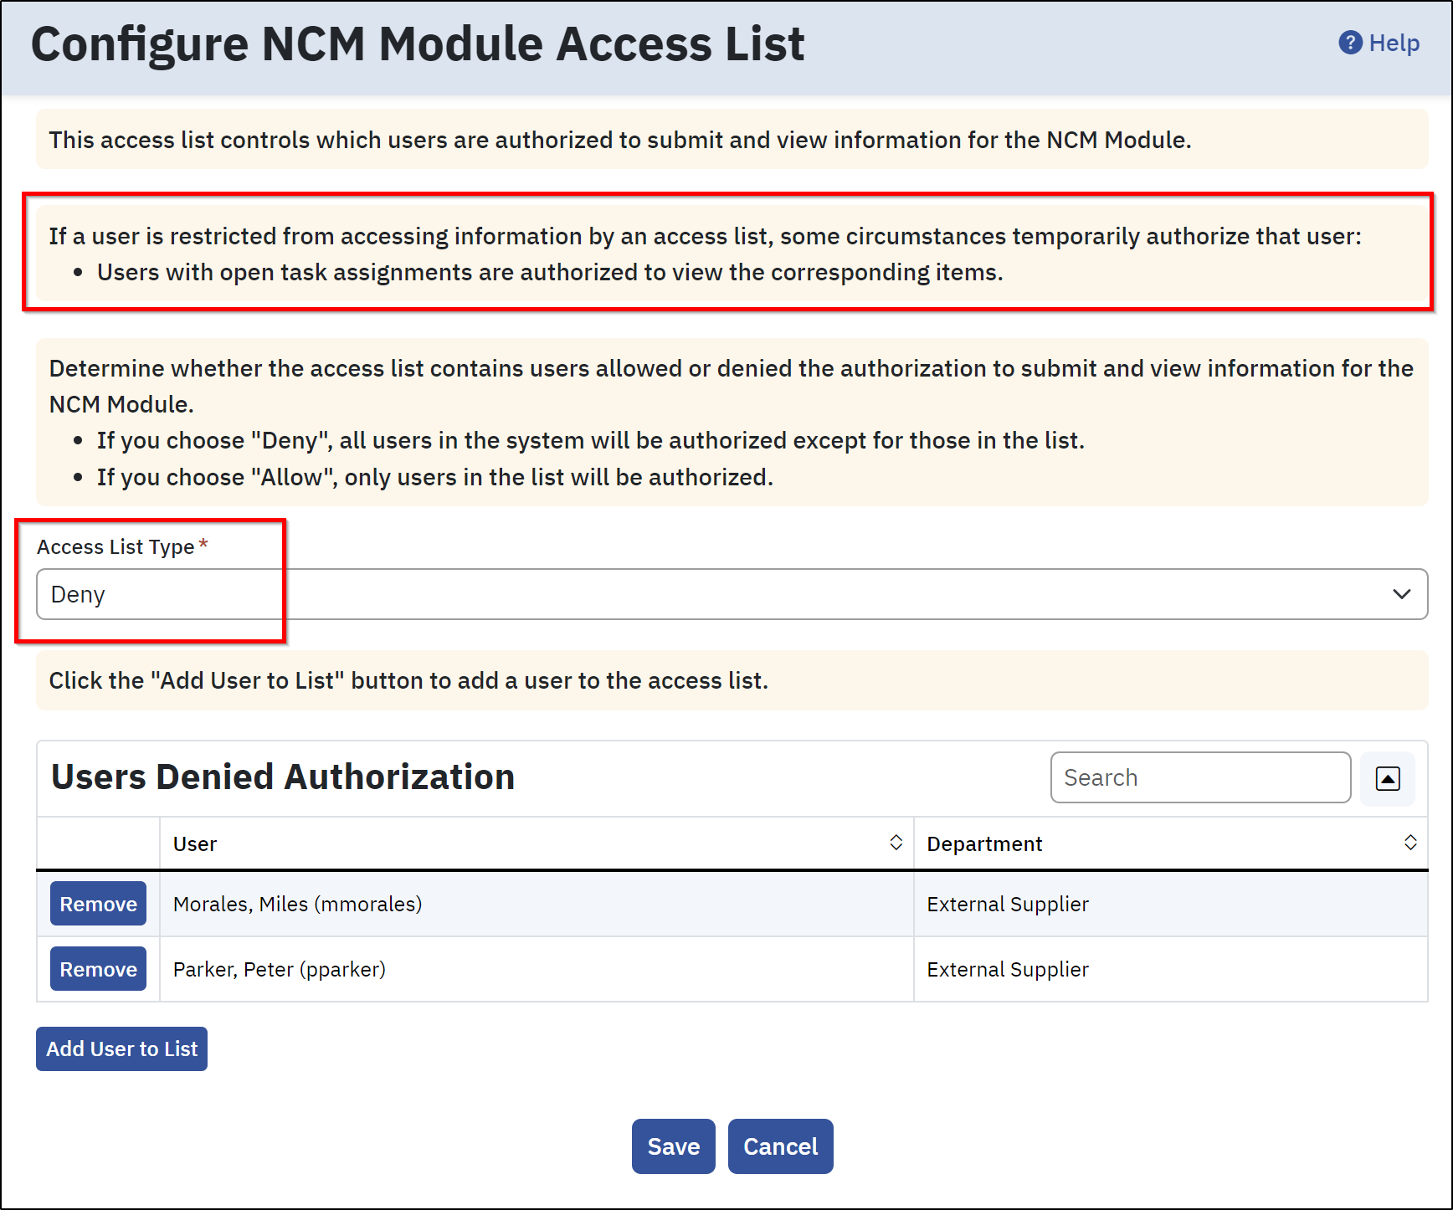

Authorize Access to Intended Items
- If limited access users can search for task assignments, the search results can expose data (e.g., Documents, Departments, Users) that they would otherwise not be allowed to see.
To disable access to the “Search for Task Assignments” link, a GAS system administrator sets Configure System Options -> Allow All Users to Search for Task Assignments? to “No.”
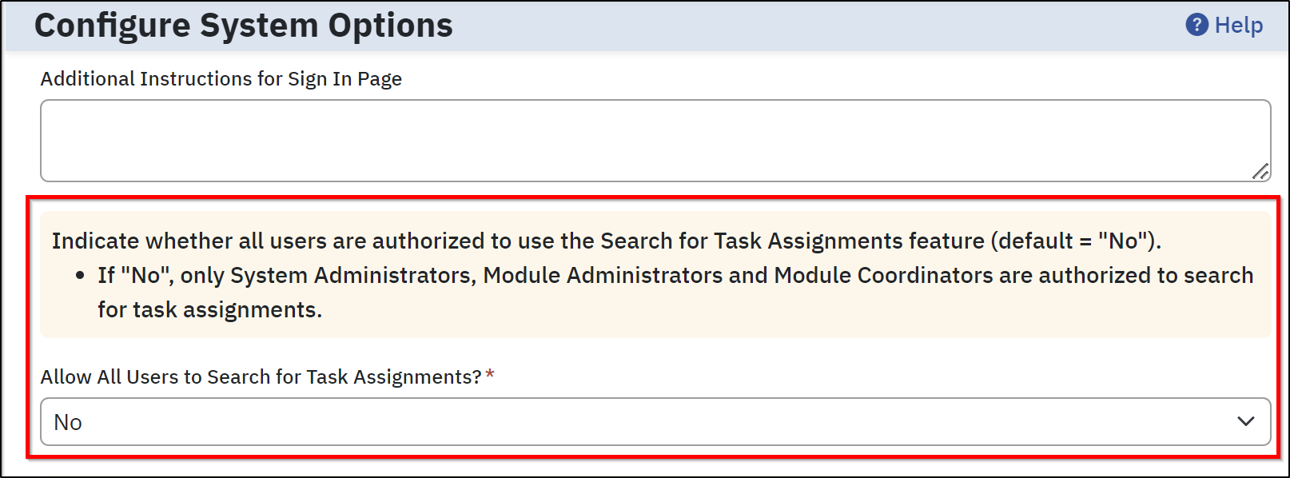
Note: This configuration option is global, so turning it off removes this capability for everyone except those noted in the accompanying task instructions (text in the yellow box).
After completing the above steps to block access to the entire Grand Avenue system, determine how limited access users will be given permission to see information. Any single or combination of the following approaches can be used:
- If open task assignments (e.g., Formal Review, Complete Training, Approve Disposition) will grant users temporary access to the related Grand Avenue data, see section 4.
- If design projects will grant users access to project deliverables, see section 5.
- If users will have permanent access to a designated set of controlled documents, see section 6.

Open Task Assignments
- Warning: Document Change Request (DCR) and Deviation Request tasks (e.g., Formal Review) temporarily authorize assignees to see all documents in the associated request. Therefore, a DCR or Deviation that contains documents associated with multiple customers/suppliers can potentially expose one company’s data to another. If customers/suppliers will be assigned change or deviation request tasks, keep document changes for each organization on separate DCRs or Deviation Requests.
Verify your configuration in a non-production environment before implementing it in production.

Design Projects
- Design Project Viewers have read-only access to the deliverables in designated design projects, even if they are blocked by the Design Control Module Access List.
To add a Design Project Viewer,
- Click Manage Design Projects
- Click Edit Design Projects
- Click Edit on the applicable design project
- In the Design Project Viewers section of the page, click Add Users
- Search for the limited access user account(s) and check the box for the user
- Click Add Selected Users
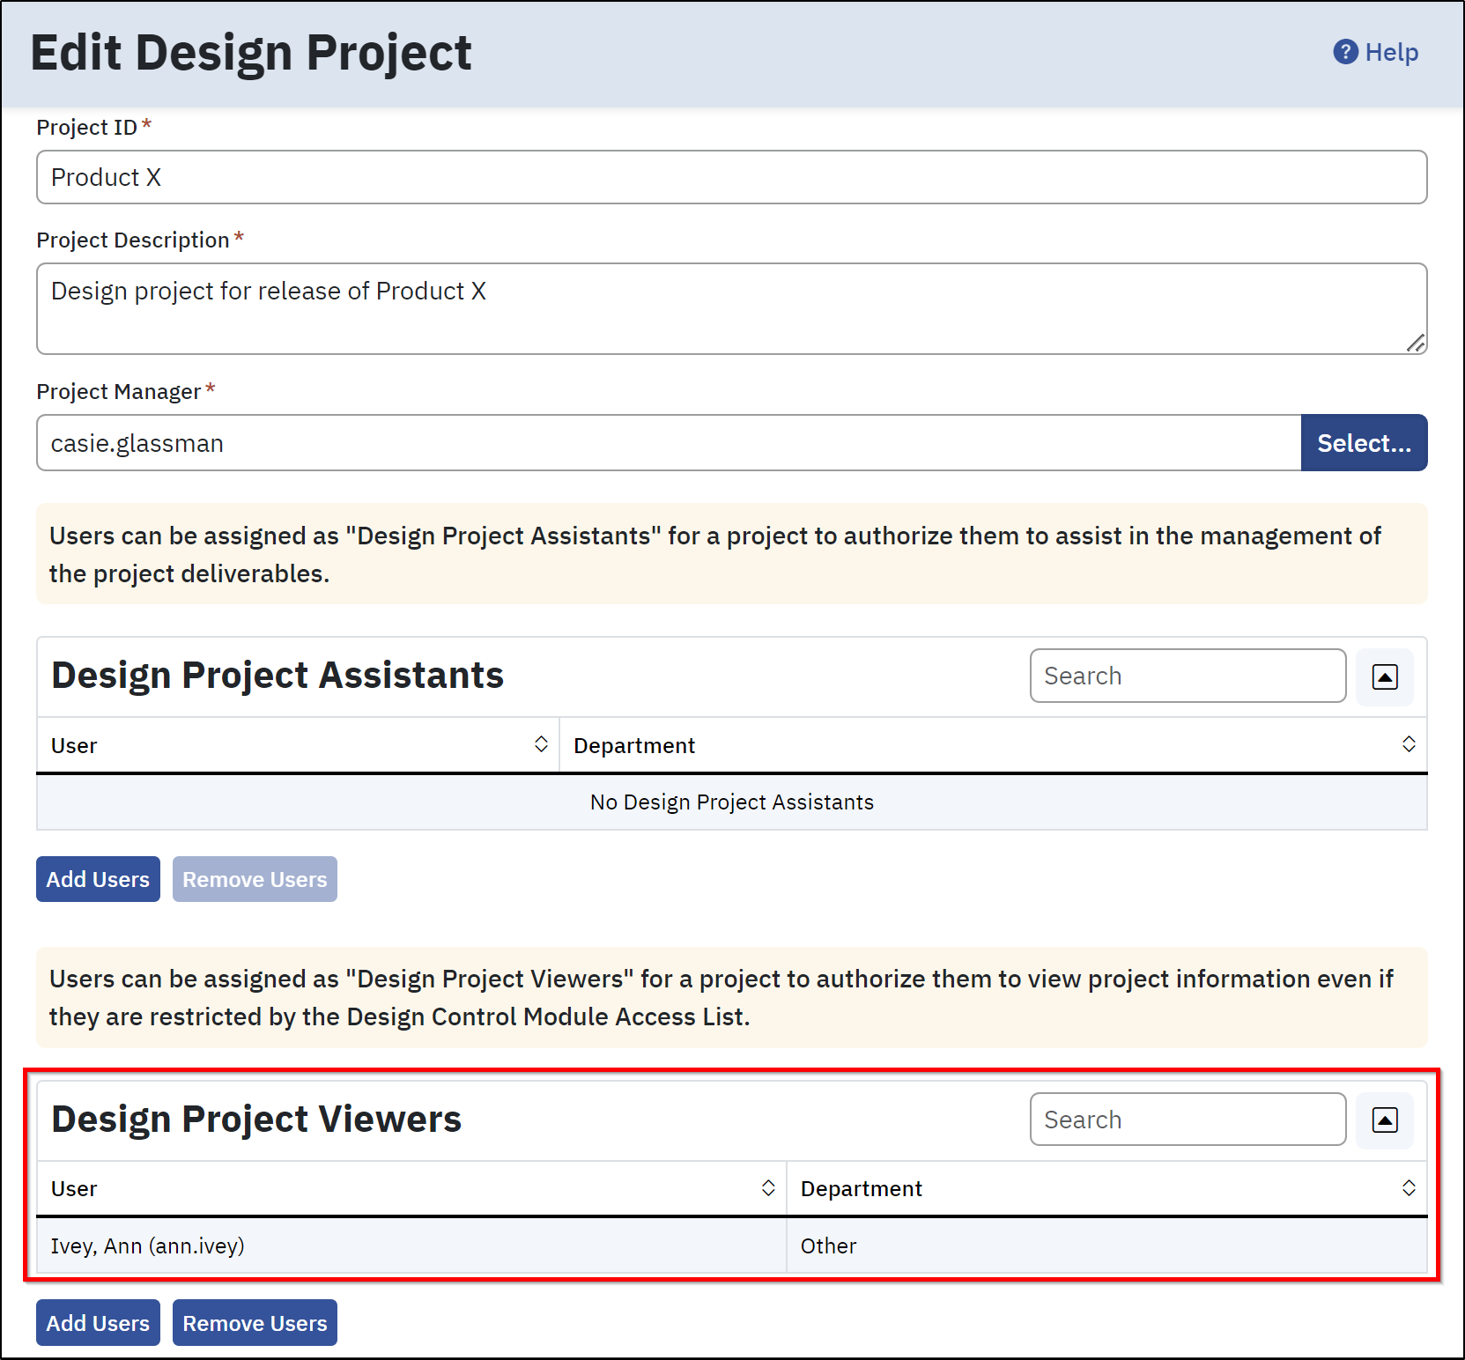

Design Project Viewers have a My Design Projects link in the left-hand navigation bar.
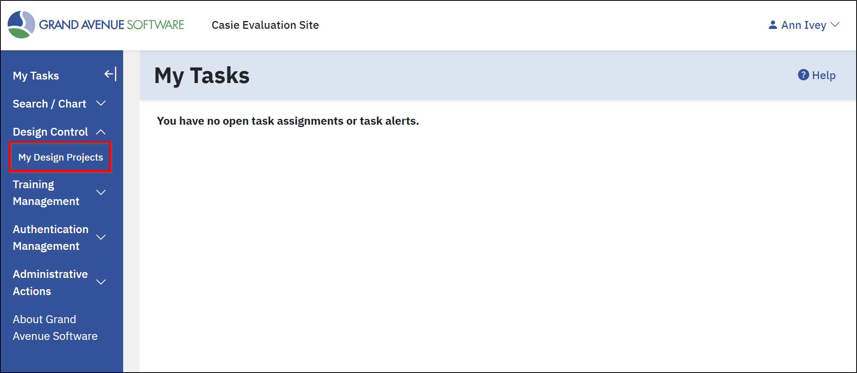

Design Project Viewers are authorized to view project deliverables. Also, by default, Design Project Viewers are authorized to view project deliverables documentation and their attached documents (including the primary document files and additional files for those documents), even if they are denied by the Document Control Module Access List.
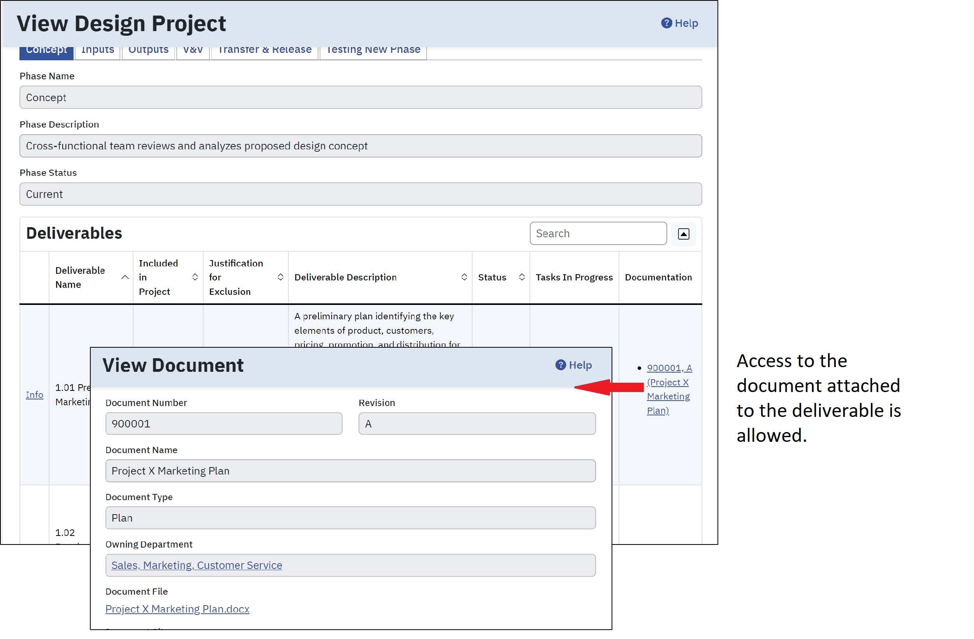
The configuration option “Allow Design Control Projects to authorize users to view associated documents?” on the Configure Document Control Process Options page allows sites using both the Document Control and Design Control modules to indicate whether limited-access users assigned as Project Managers or Project Viewers for open Design Projects will be temporarily authorized to view all revisions of documents that have been attached to deliverables for that project. The default setting is “Yes”.
Document Control Process Option
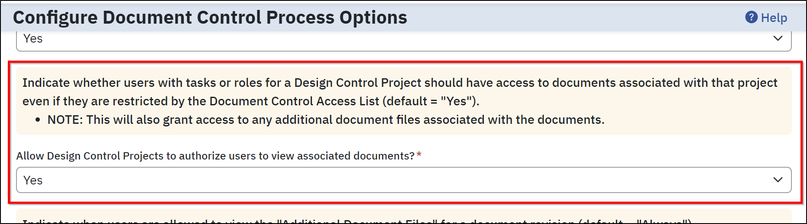
If the Document Control Process Option is set to “No”, then Design Project Viewers are not authorized to view project deliverable documentation if they are denied access by the Document Control Module Access List.
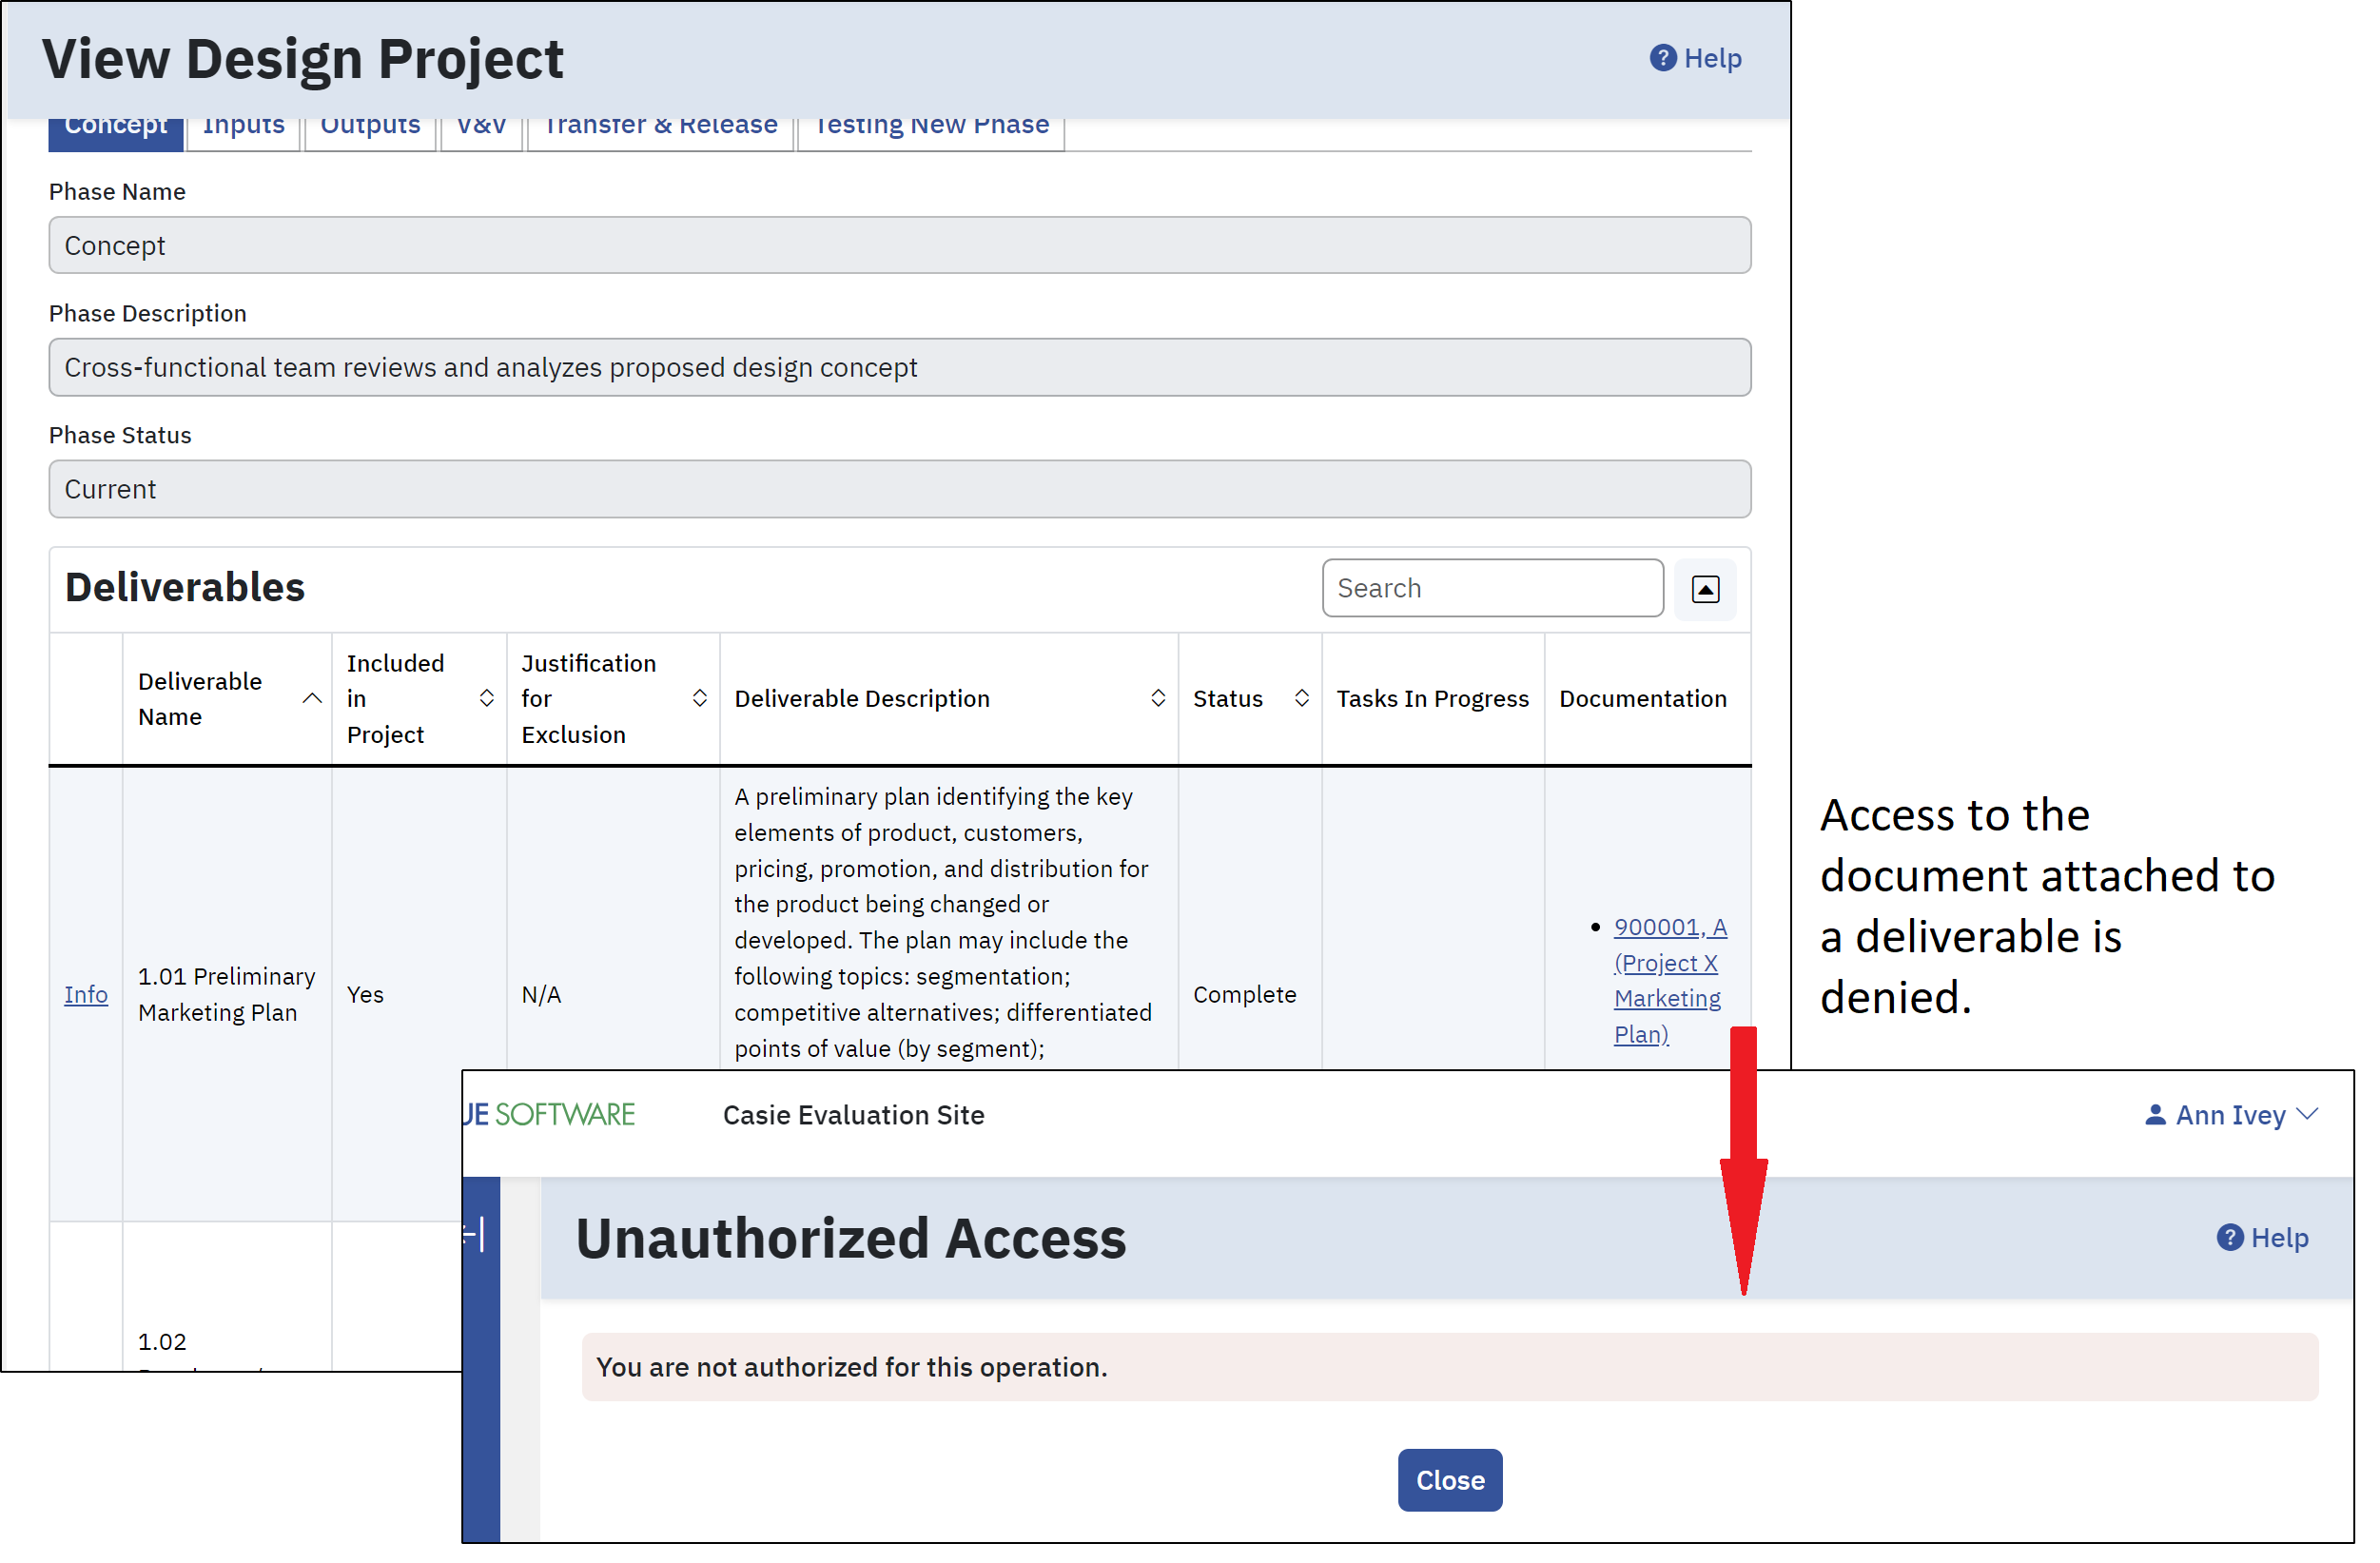
Verify your configuration in a non-production environment before implementing it in production.

Document Collections
- Create new Document Collection Types as needed.
- Document collections are assigned a Document Collection Type based on the answers to the following questions:
- Assign tasks for document changes?
- Always require tasks when adding and removing documents?
To create a new Document Collection Type,
- Click Configure Document Control
- Click Define Document Collection Types
For limited access users, such as an auditor who has temporary access to GAS for only the duration of an audit, create a Document Collection Type with the settings shown below (“No”).
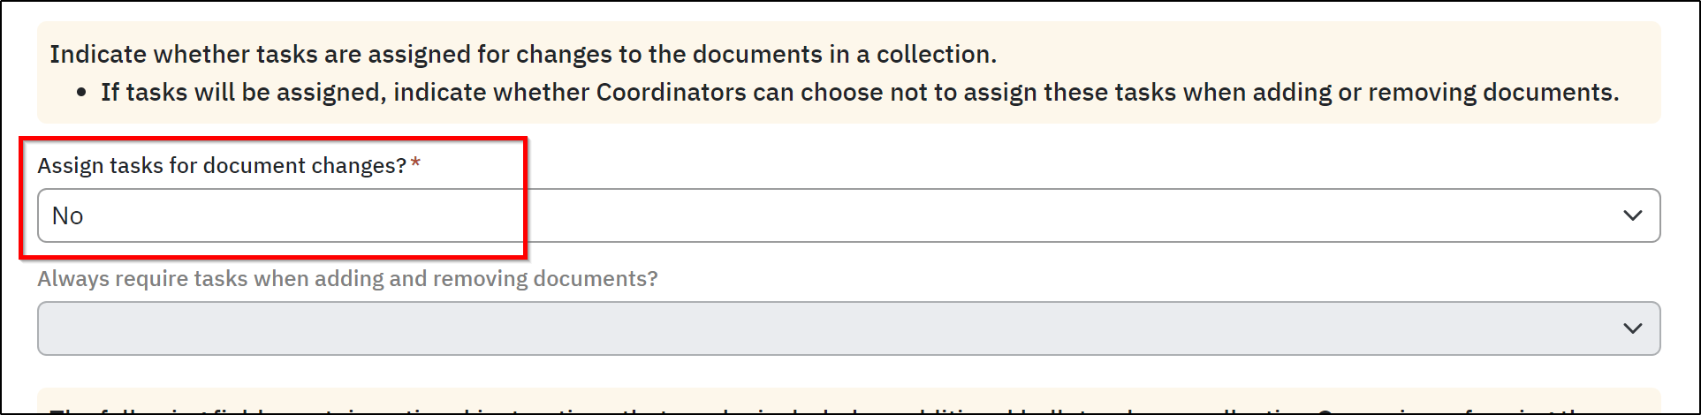
For limited access users such as customers or suppliers who must be notified as their collection documents change, create a Document Collection Type with the settings shown below (“Yes”/” Yes”). With these settings, collection owners receive email notifications and are assigned GAS tasks to update their collections when documents are added, revised, or removed.
Example: Electronic signoff of a supplier’s document collection task is your record/evidence that the supplier was notified of the change.
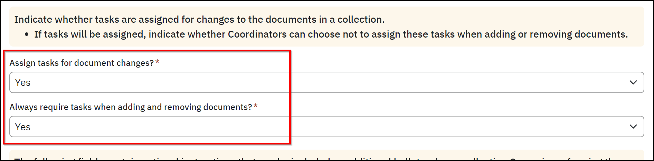

- Add document collections for audits, customers, suppliers, etc. using the applicable Document Collection Type from the previous step.
The options for configuring document collections for limited access users depend on the Grand Avenue Software version. See the table below for details.
GAS Versions | Which limited access users can view primary document files for documents in the collection? | Can limited access users view Additional Files for documents in the collection?
15.1 and earlier | Collection Owner | None
15.2 through 15.5 | Collection Owner | Optional depending on the value of Document Collection Type configuration option “Allow collection owners to always view Additional Files for documents in the collection?”
15.6 and later | Collection Owner and Collection Viewers* | Optional depending on the value of Document Collection Type configuration option “Allow collection Owners and Viewers to always view Additional Files for documents in the collection?”
*In versions 15.6 and later, limited access users, such as auditors, can be given access to Document Collections as Collection Viewers rather than being required to own the collection.

- Prior to GAS 14.6, Document Collection tasks assigned to users other than Document Collection owners temporarily authorized assignees to view both the Document Collections and the documents associated with each task, even if the user’s account was blocked from viewing documents by the Document Control Module Access List. Starting at GAS 14.6, Document Collection tasks grant temporary authorization to view only the Document Collection and do not grant additional access to the associated documents.

Verify your configuration in a non-production environment before implementing it in production.

