Document Number: GAS- 1145
Revision: A

Table of Contents
Introduction 2
Prerequisites 2
Procedure 2

Introduction
The name of a Document Type can’t be changed. Follow the steps below to rename a Document Type for which instances of documents already exist.

Prerequisites
- You must be the Document Control Module Administrator to perform this procedure
- You must be familiar with the procedure for performing administrative updates in GAS

Procedure
- Create a new document type with the desired periodic document review settings and Approving, Observing, and Affected Departments.
Example: If the current document type is “Operating Procedure” and you want to change the type name to “Standard Operating Procedure”, create the new document type “Standard Operating Procedure.”
- Download and open the Administrative Update for Field Values template. You won’t populate this template; it’s downloaded here only as a reference for formatting your CSV file.
Click Manage Documents > Administrative Update for Document Field Values > Download Template
- Select one of the options below to search for documents of the original Document Type.
- Option 1: You want no revisions of the original Document Type to exist and no new documents of this type to be created. Change the Document Type of all revisions of documents of this type and delete the original document type.
  - Click Search for Documents
  - Clear all fields on the Search for Documents page, including Max # of Items to Display
  - Set the Document Type to the original value
(Example: “Operating Procedure”)
  - Search
- Option 2: You want to keep non-effective revisions at the original Document Type, but prevent new documents of this type from being created. Change only the effective revisions to the new Document Type and deactivate the original document type.
  - Click Search for Documents
  - Keep the default Status “Effective”
  - Clear the Max # of Items to Display
  - Set the Document Type to the original value
(Example: “Operating Procedure”)
  - Search
- Click Export Results to Excel
- Open the exported CSV file and remove all columns except
  - Document Number
  - Revision
- Add a third column for Document Type (this is the column shown as “Field Value” in the downloaded template) and populate the column with the new Document Type.
(Example: “Standard Operating Procedure”)
- Make sure the columns are in the exact order shown in the downloaded template.
Example:
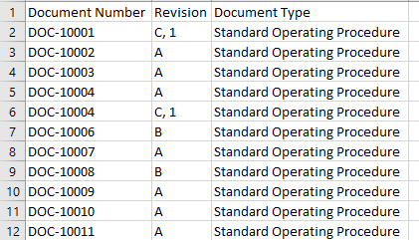

- Save the file, keeping it in CSV format
- Use the CSV file created to perform an Administrative Update for Field Values
- Click Manage Documents > Administrative Update for Document Field Values
- Select “Document Type” as the Field to Update
- Upload the CSV file
- Enter a description of why the change is being made
- Click Update Document Field Values
- Deactivate or delete the old Document Type

