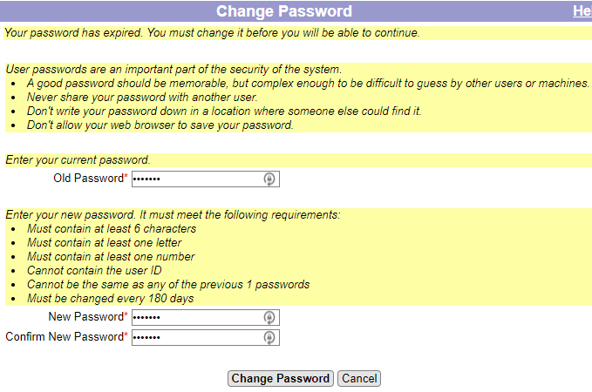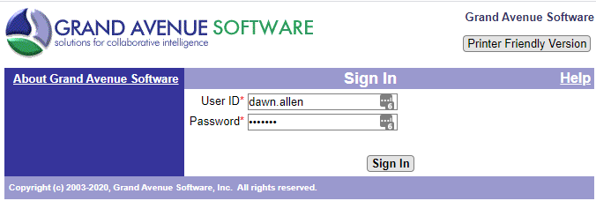

**First time login**

* You are required to change your password the first time you log in (and any time after an administrator has reset your password)

Logging in to Grand Avenue

Open your web browser to [https://*your-site*.grandavenue.com/GrandAvenue](https://your-site.grandavenue.com/GrandAvenue)

* Make sure to use https
* Create a browser bookmark/favorite using this URL

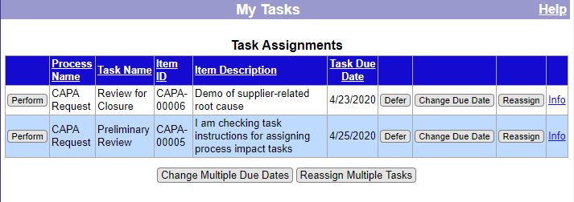

**My Tasks**

* Your Grand Avenue “Home” page
* Everything requiring your action is on this page

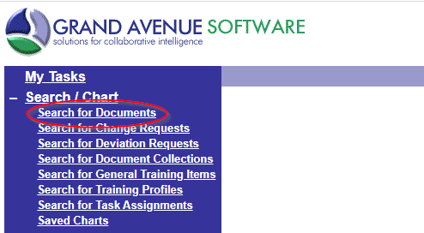

Search by **Document Number** and/or **Document Name**

* Fields can have partial values

Click the **Search for Documents** link in the left-hand navigation bar

Searching for Documents

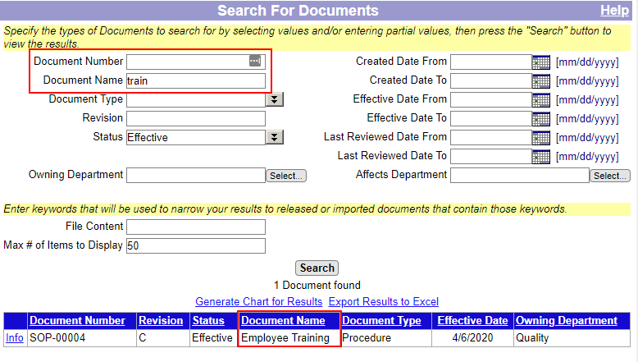

Search for all documents whose name contains “train”

Found document with name “Employee Training”

Searching for Documents

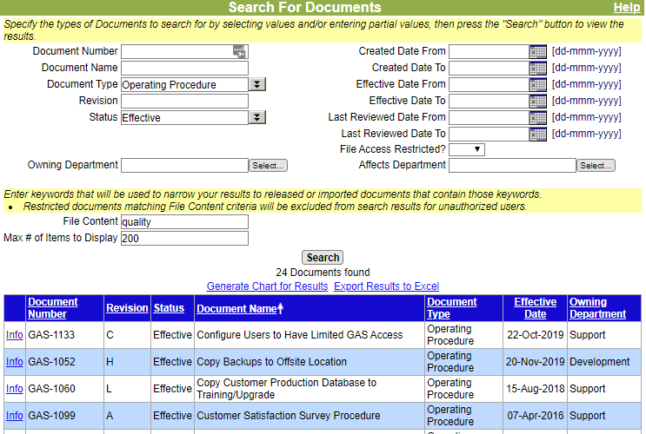

Search for all operating procedures containing the word “quality”

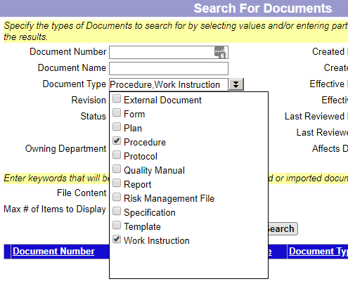

Search by **Document Type**

* Click the down arrows to see a list of possible document types
* Multiple **Document Types** may be selected
* Click the down arrows again to close the drop-down list

Search for procedures or work instructions

Search by **File Content** searches the contents of document files and document metadata, e.g.

* Microsoft Office files
* Generated PDF files

Opening Documents



Click the **Info** link

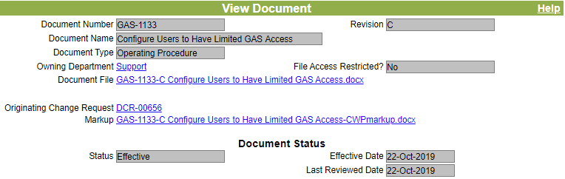

**Download the document** by clicking the “Document File” link

* The file downloads to your local computer
* Depending on the file type and your web browser settings, the file **may** open automatically.

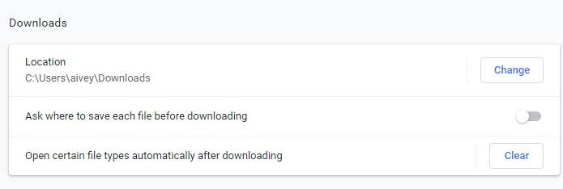

Example setting for **Chrome** web browser to open files automatically after downloading

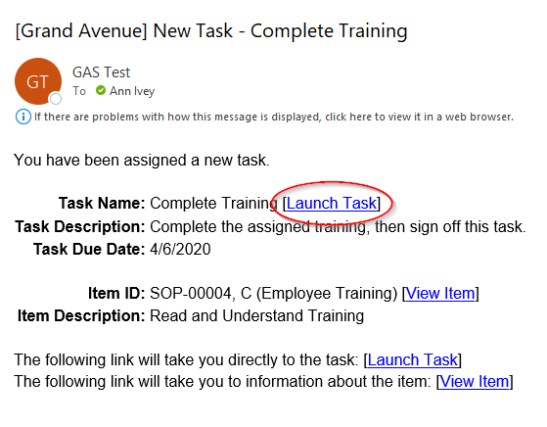

Perform task from **email** **notification**

* Receive an email from Grand Avenue saying that you have been assigned a new task
* Click the Launch Task link
* Log in to Grand Avenue

Example Task: Read and Understand Training

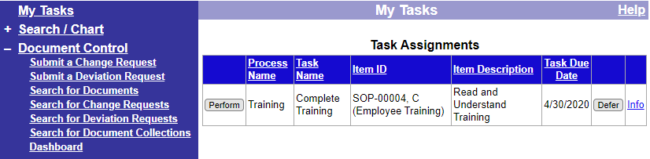

Perform Task directly from **My Tasks** page

* Go to **My Tasks**
* Click “Perform” on the task
* Download the document by clicking the “Document File” link on the task
* Read the document

Example Task: Read and Understand Training

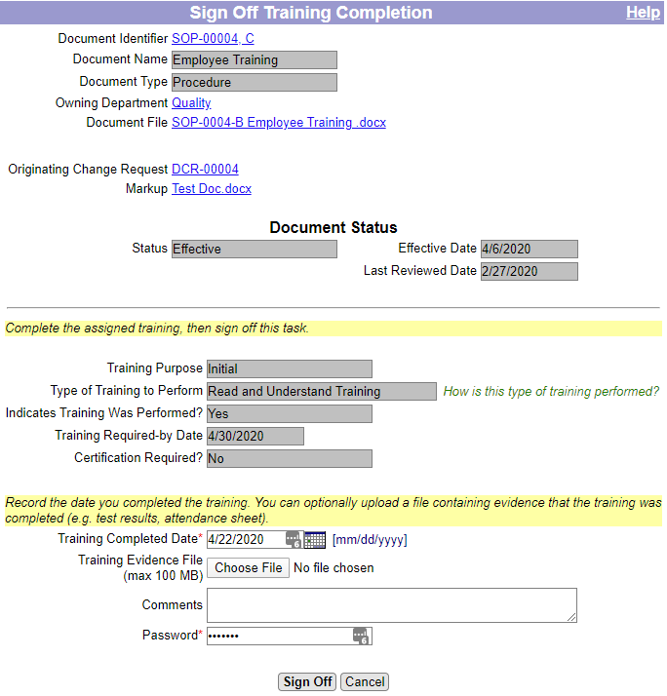

**Sign Off Task**

* When you’ve completed the task, go to the bottom of the page, enter your password and click “Sign Off”

Navigation Tips

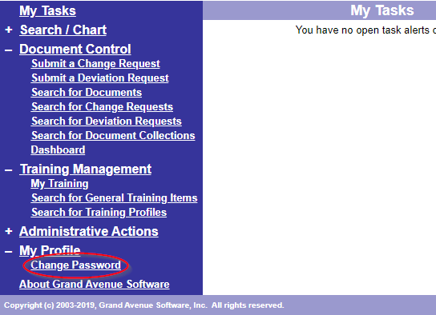

**Navigation Bar**

* sections expand and contract



Click any column heading to sort by that column

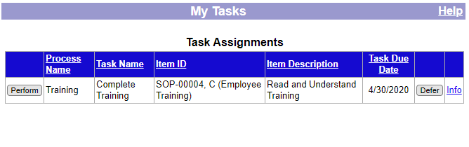

Online **Help** link is on every page

Contact for questions: __________________________________

Miscellaneous Tips

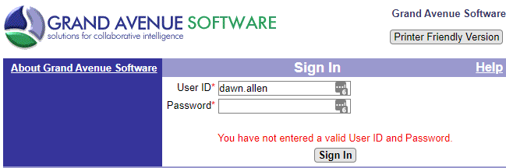

Note: You will be temporarily locked out for *xxx* minutes after *yyy* consecutive login failures

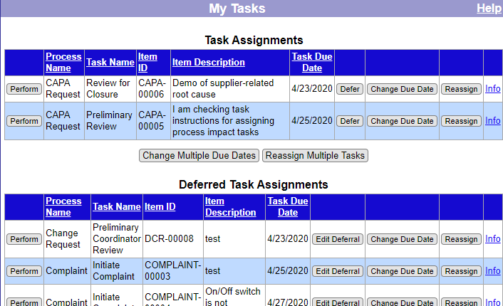

**Defer a Task**

* Deferring a task does not change the due date. It simply puts the task in a separate “Deferred Task Assignments” list for organizing lower priority tasks